

**Pastor Michael Sealy**

**Associate Pastor Jason Peasley**

**Sunday Worship Service**

**Oct. 20, 2024 † 10:30 am**

|  |  |
| --- | --- |
| **Service Leader** | Paul Visser |
| **Welcome & Announcements** | |
| **Series Title** | People Need the King |
| **Sermon** | **Holy Is the Lord** |
| **Scripture** | 2 Samuel 6 |
|  |  |

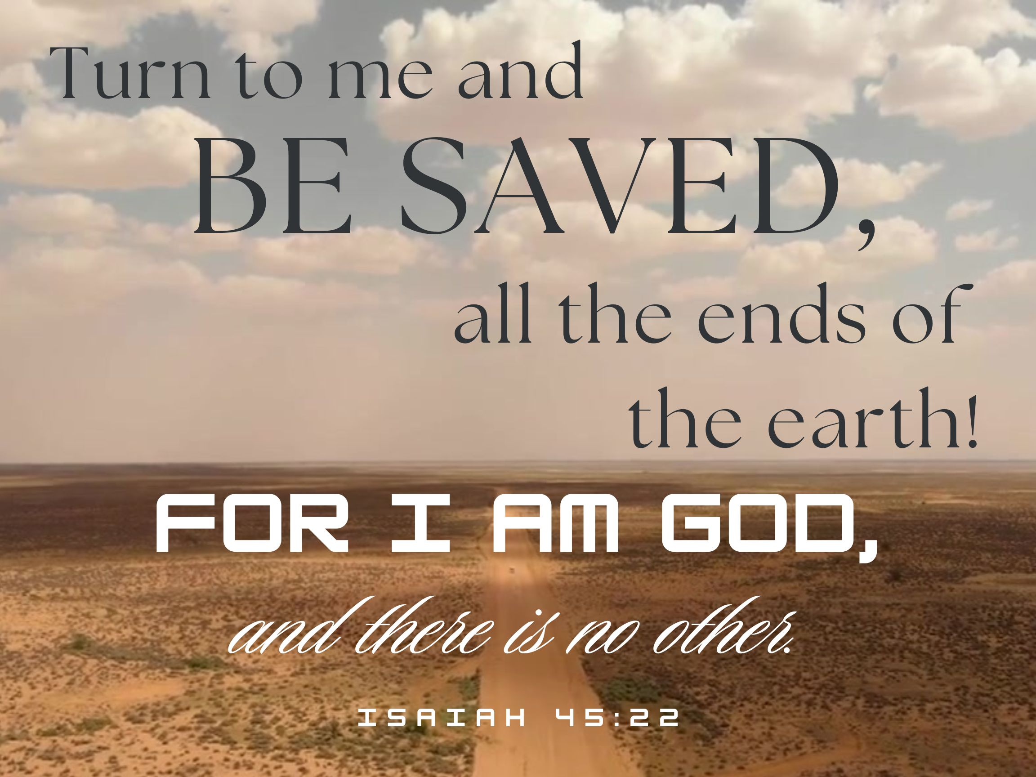Memory Verse – Isaiah 45:22

A warm welcome to those visiting with us today.

If we can assist you in any way, please speak to one of the ushers.

Welcome!!

Messages

**Operation Christmas Child** –Shoeboxes are available at the front entrance and on the front pew. Deadline to return your boxes to the church is **Nov. 17th.** You can also pack an online box on their website at: packabox.ca

Upcoming Events

**Membership classes** will be held **Sunday mornings** at **9:15 am** in the boardroom. For all who are interested in the what and how of church membership, join us on the following Sundays: **Oct. 6th, 20th, and 27th** For more information see Dan Quick.

Regular Events

**Adult Sunday School** ~ **Sundays** @ **9:30 am** in the Lower Auditorium for Adults and Youth.

**Sunday Evening Discipleship** ~Families are invited on Sunday Evenings at **6:30 pm** in the Lower Auditorium where we will be working through the 12-week curriculum *How People Change* by Timothy Lane and Paul David Tripp. The evenings will consist of a teaching time, discussion, and time of prayer. Kids are welcome to play in the gym during this time.

**Men’s Ball Hockey** ~ Select **Monday** nights at **7 pm** in the gym. Fellowship, fitness & a whole lot of fun! Call or text Pastor Jason if interested in joining or for more details. 226-345-9722.

**Women’s Bible Study** ~ **Tuesdays** at **7:00pm** studying the books of 1, 2, and 3 John using Jen Wilkin’s *Abide* study.

**Coffee Break** ~ This lively group gathers weekly for coffee, fellowship & shuffleboard or other board games followed by a time of Bible Q&A with the Pastor. **Wednesday** mornings at **9 am**. It’s a great way to get to know one another, invite a friend!

**Youth Bible Study** ~ Meeting every **Wednesday** from **7-8:45 pm** in the lower auditorium, study groups for both Jr Youth (Gr 6-8) and Sr Youth (Gr 9-12).

**Men’s Bible Study** ~ **Wednesdays** at **7pm** in the Bible study room located in the CE Building.

**Ask the Pastor** ~ All are welcome 2nd Sunday of the month @ **3:30 pm** in the Lower Auditorium.

**Prayer Meeting** ~ The last Sunday of the month @ **3:30 pm** in the Board Room.

 Sunday School

**Gr. 1 to Gr. 5 upstairs (9:30-10:15**)

\**Registration opens at 9:15*

**Preschool to SK downstairs (during service)**

\**Registration opens at 10:00*

**\*Classrooms are located across the bridge in the CE Building\***

Missions

**Bible Club Fundraiser** ~ Fall Soup & Dessert Night. Enjoy bottomless bowls of soup, delicious desserts & door prizes! Supper starts at 5:30 pm. $5 at the door and free will offering each evening. Friday, Nov.1st at Harrow Baptist Church and Saturday, Nov. 2nd at the Leamington Evangelical Mennonite Church. This fundraiser supports local after school, at home, homeschool and backyard Bible Clubs across Essex County.

Church Library – Books of the week

* Christian Struggles – Gentle and Lowly: The Heart of Christ for Sinners and Sufferers Hardcover *by Dane C. Ortlund*
* Autobiography – Evidence Not Seen: A Woman's Miraculous Faith in the Jungles of World War II *by Darlene Deibler Rose*
* Youth – The Chronicles of Narnia Series *by C.S. Lewis*

Financials

|  |  |
| --- | --- |
| Year to Date – Sep. 30, 2024 | |
| Revenue | 283,234.51 |
| Expenses | 275,941.59 |
| Surplus/Deficit | 7,292.92 |

Sermon Notes

#1 – Disregarding God’s holiness is dangerous. (Verses 1-7)

#2 – Appreciating God’s holiness opens the way to blessings

and worship. (Verses 8-15)

#3 – Enjoying God’s holiness is good for people, but some

will detest it. (Verses 16-23)

3 Fox St. Leamington, ON N8H 4W9 (519) 326-5491

**Office Hours: Tues-Fri, 9 am-1pm** Email: firstbap@cogeco.net

wPastor Mike 519.816.5491 w Pastor Jason 226.345.9722 w Joanne 519.324.6828

www.fbcleamington.com